**1.Write a c program to evaluate linear search**

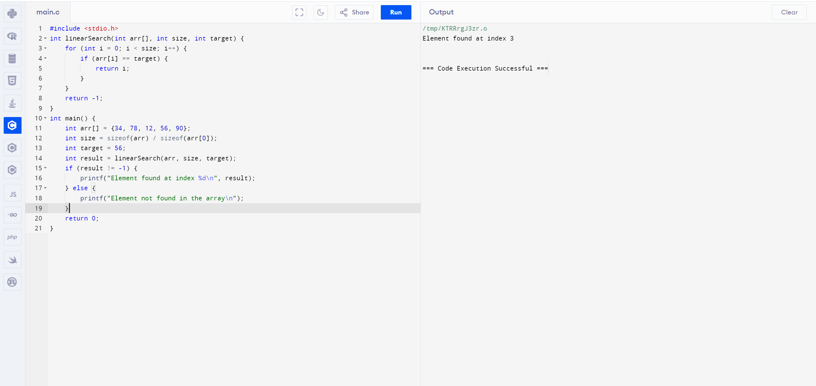

**2.Write a c program to evaluate binary search**

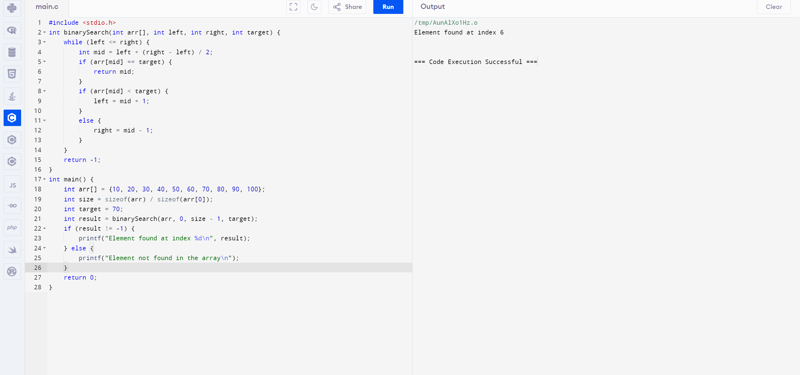

**3.Write a c program to conevrt infix to postfix (stack application)**

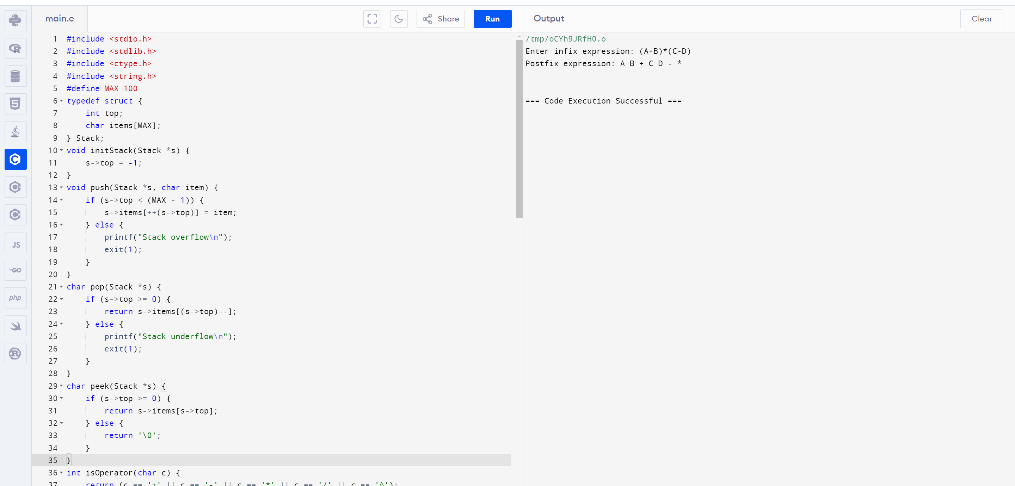

**4.Write a c program to evaluate postfix expression(stack application)**

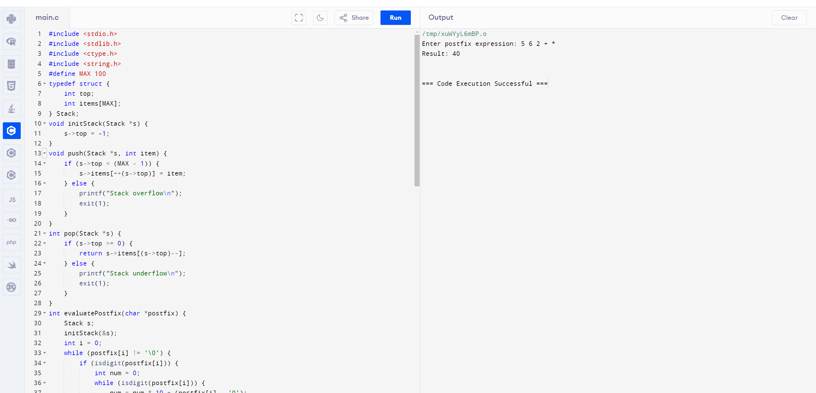

**5.Write a c program to evaluate the balanced symbols**

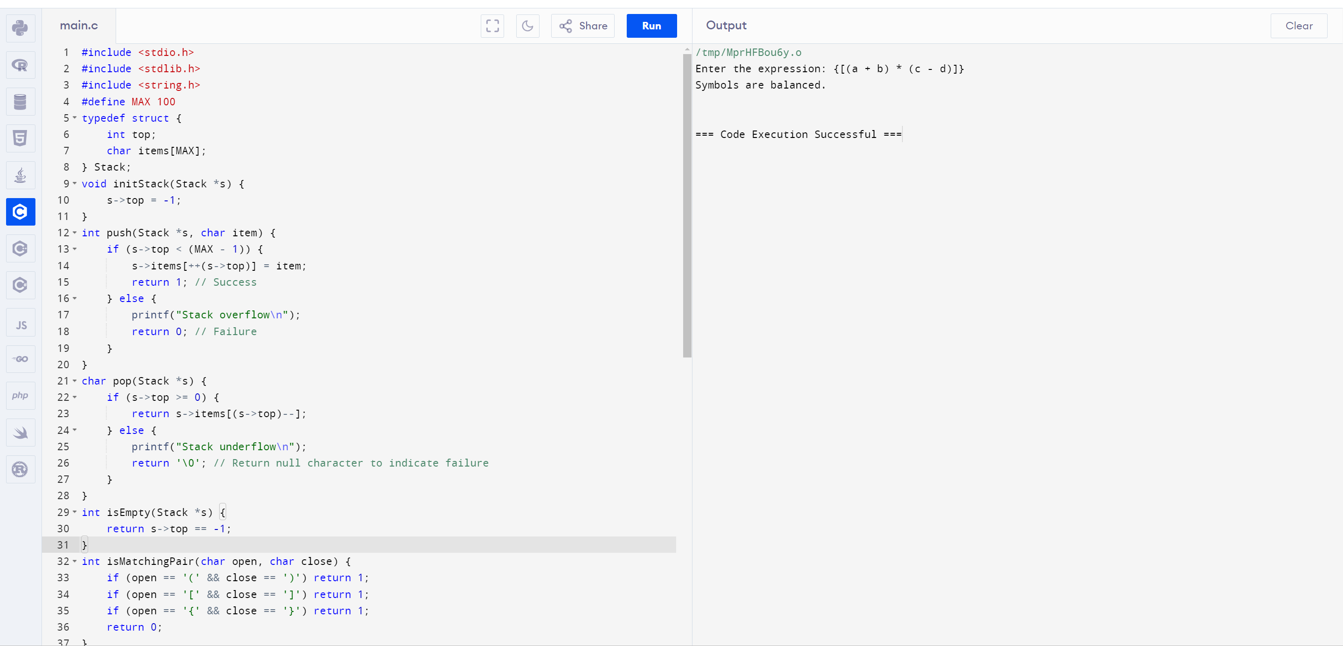

**6.write a c program to evaluate array implementation in queue**

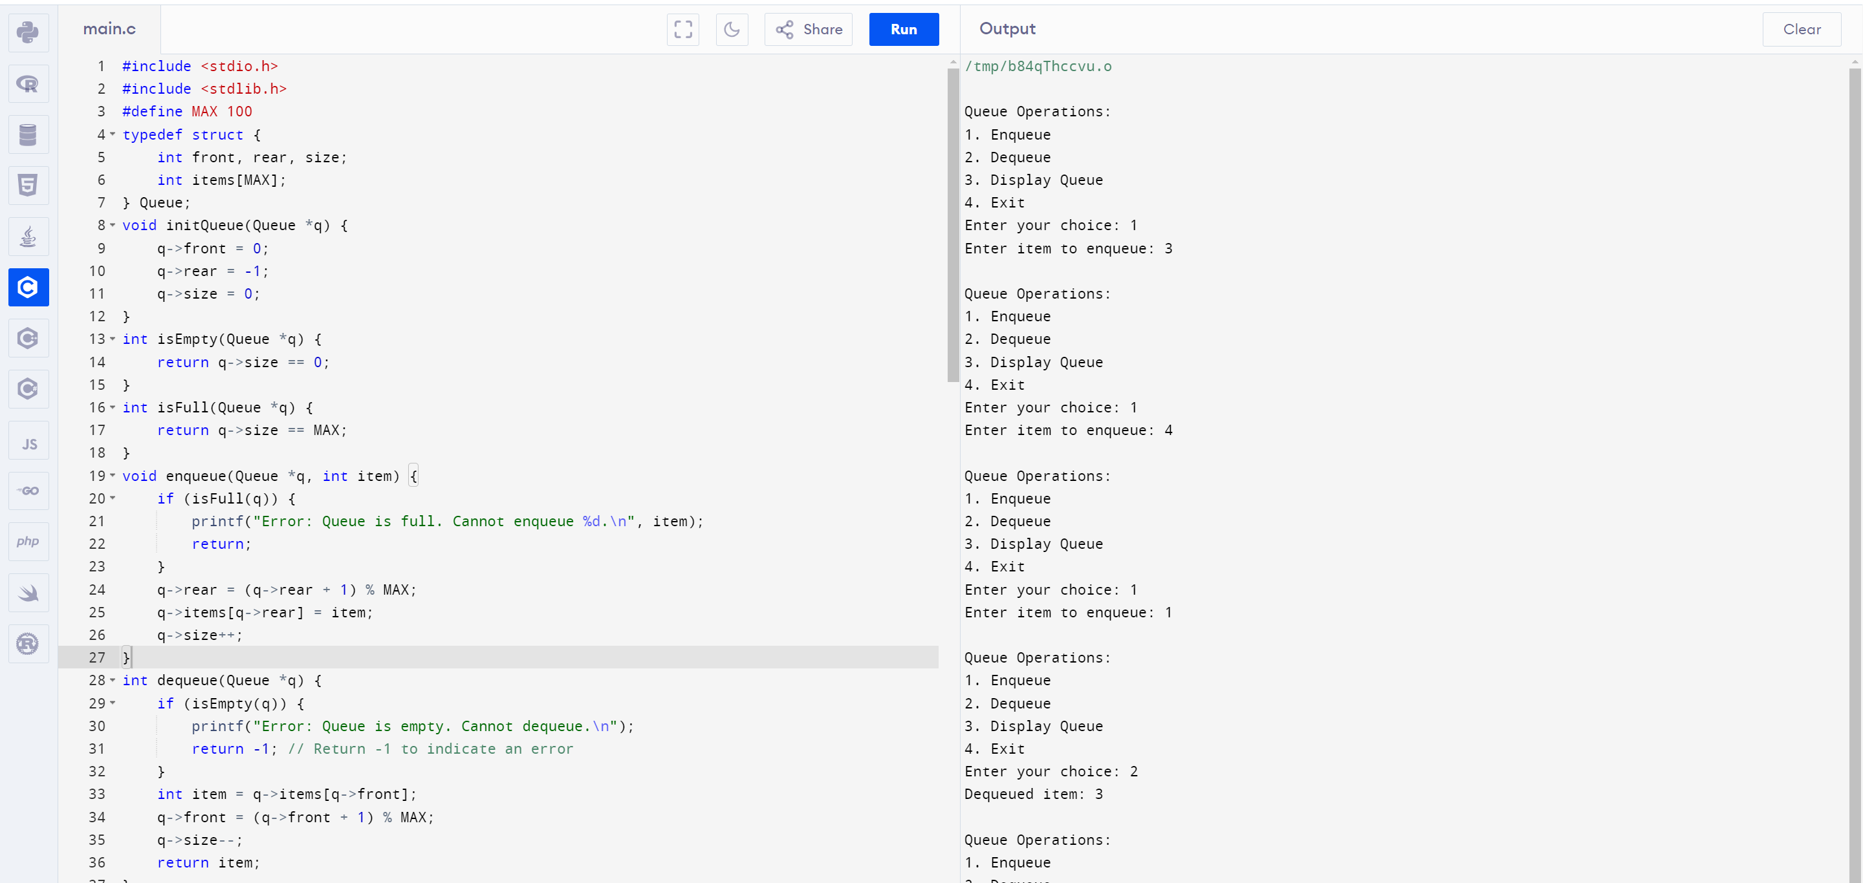

**7.Write a c program to find the linked list implementation**

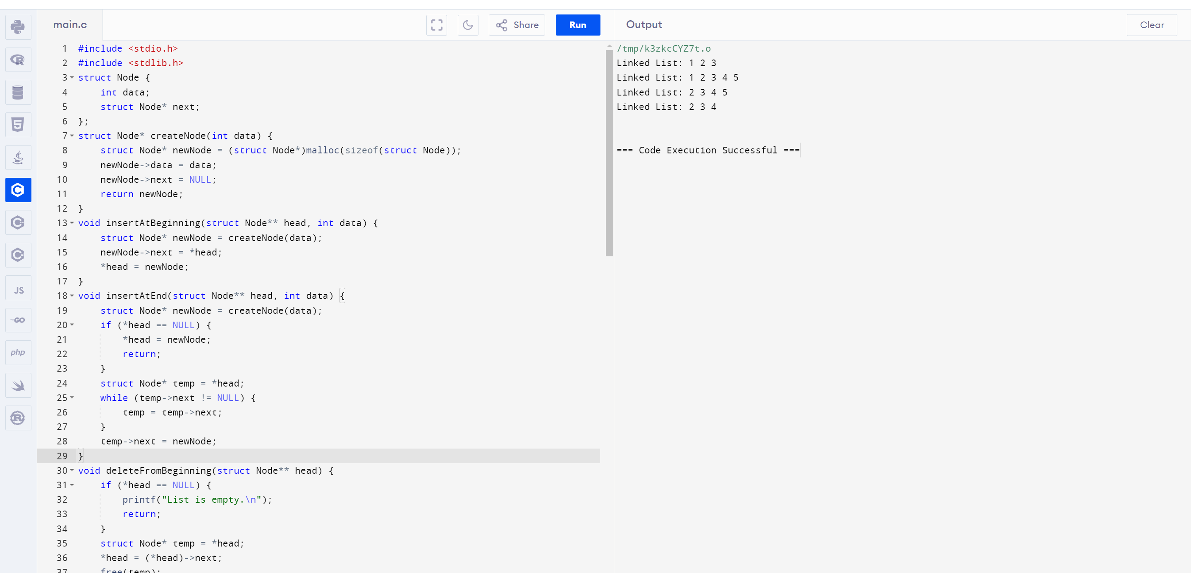

**8.Write a c program to find the circular queue**

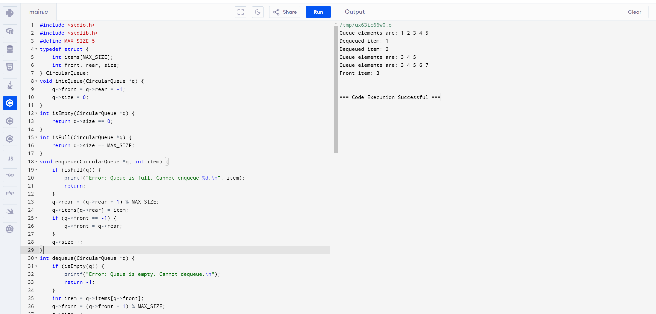

**9.Write a c program to find the priority queue**

